TEAM ID | SWTID-2026-8765
PROJECT TITLE | Strategic Product Placement Analysis using Tableau
MAX MARKS | 2 MARKS

CHAPTER – III
REQUIREMENT ANALYSIS
3.1 – Customer Journey Map
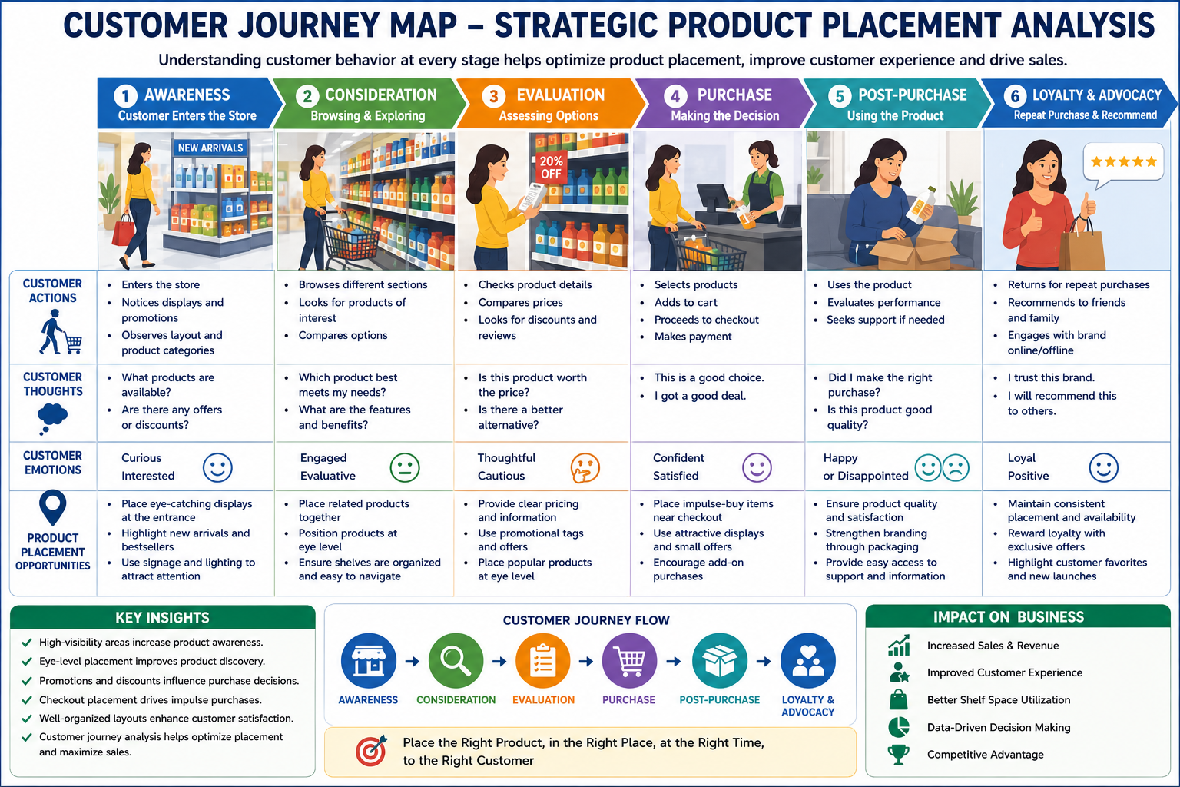

Customer Journey Flow

1. Awareness
- Customer enters the store.
- Notices promotional displays and featured products.
- Becomes aware of available products and offers.

2. Consideration
- Explores product categories.
- Compares alternatives.
- Evaluates product placement and visibility.

3. Evaluation
- Reviews product information and pricing.
- Checks discounts and promotions.
- Considers value for money.

4. Purchase
- Selects desired products.
- Makes purchase decision.
- Completes checkout process.

5. Post-Purchase Experience
- Uses the purchased product.
- Assesses product quality and satisfaction.
- Forms opinions about the brand.

6. Loyalty & Recommendation
- Returns for repeat purchases.
- Recommends products to others.
- Develops brand loyalty

